


For more information, contact us at support@nayax.com

Nayax Pulse QR
Manual

ã Property of Nayax. All rights reserved
Table of Contents
Contents
General Information 4
1. Overview 5
2. The Nayax Offering 6
3. Pulse Functionalities 7
3.1. Pulse Purchase Flow 7
3.2. Available Pulse Types 8
3.2.1. Default Pulse 8
3.2.2. Invert Pulse 8
3.2.3. Closed Circuit 8
4. Hardware Installation 9
4.1. Device Cable Connection 10
4.2. Device Connection to Power Supply 11
4.3. Device Machine Connection 11
4.3.1. Wire Connection Without a Relay 12
4.3.2. Wire Connenction Using the Relay 15
4.4. Additional Cable Wires 17
5. NayaxVend (DCS) Attributes Setup 17
5.1. Configuring Attributes in NayaxVend 17
5.2. General Attributes 19
5.2.1. Attribute-Naming Convention 19
5.2.2. General Mandatory Attributes 19
5.2.3. Inhibit 20
5.2.4. General Optional Attributes 21
5.3. Pricing Methodology 25
5.4. Single Price per Pulse Line 26
5.4.1. Single Price Configuration per Nayax Device 26
5.4.2. Pulse 2 as Prize Win 29
5.4.3. Pulse Combo Machines 29
5.5. Multiple Price for a Machine 32
5.5.1. Linear Price Increment Attributes 32
5.5.2. Price List Attributes 34
5.5.3. Multi Price Additional Attributes 35
5.6. Count-Up Mode – Pay as You Go 37
5.6.1. Count-Up Active/ Inactive Time 37
5.6.2. Count-Up Mode Attributes 38
5.6.3. Buying Process 39
5.6.4. Stop Count Up 40
5.6.5. Power-off 40
5.6.6. Count-Up Pulse 41
5.7. Count-In Mode 43
5.7.1. Wires 44
5.7.2. Count-In Mode Attributes 44
5.7.3. Comparison Between Count-Up and Count-In 45
6. Frequently Asked Questions 46
7. Appendix 1 - Hardware Electric Schemes 48
7.1. HW Pulse Interface 48
7.2. Hardware Inhibit Interface/ Door Open 51
7.3. Pull-up Installation 53
7.4. Nayax Cables 54

General Information
This section explains the classification of the manual and the purpose for which it is intended.

Organization of the Manual
The user manual consists of six sections, namely: General Information, Device Overview, Getting Started, Appendix 1 - Tests Prior to Repair, Appendix 2 - FCC & IC Regulations and Safety & Handling Instructions.
The Overview section explains the purpose for which the manual is intended.
Nayax Offering section that describes the devices operating with pulse functionalities.
Pulse Functionalities section explains the functionalities and its workflow.
Hardware Installation section describes how to connect the device.
Pulse Parameters Setup section relates to setting up the pricing policy in accordance to the available options.
Frequently Asked Section addresses various questions that could help in troubleshooting and resolving issues.
Lastly, the Appendix - Hardware Electric shows the various hardware pulse output interfaces for measuring pulse inputs.

Overview
This manual details the Nayax solution for machines that are operated by pulse, after payment is received. Several configuration types are available, providing the different behaviors required by these machine types.

The Nayax Pulse solution can be used for verticals such as:

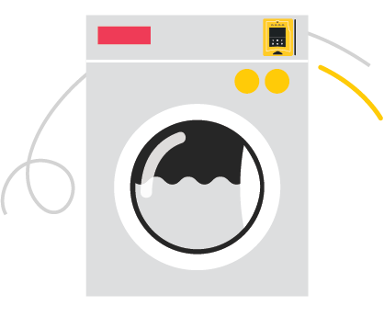 | 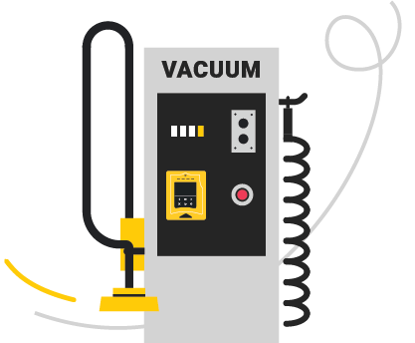 |  | 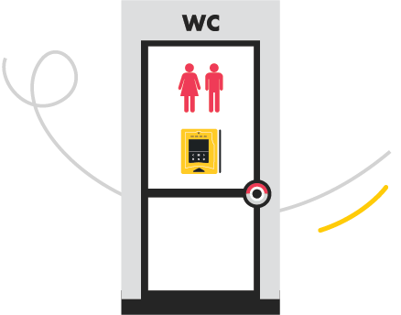
 | 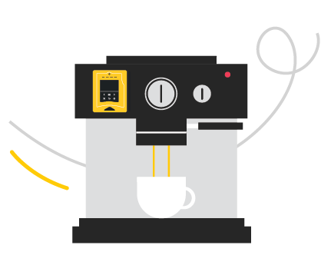 | 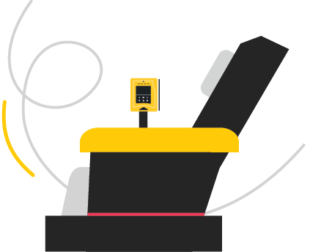 | 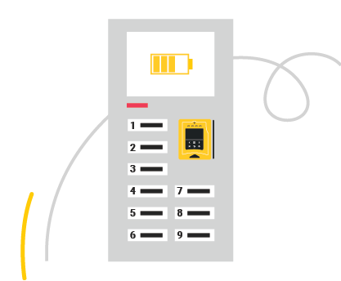
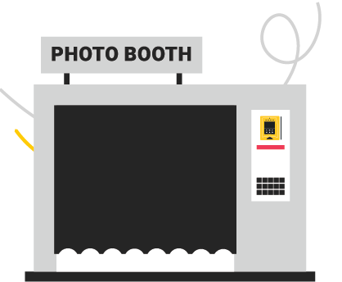 | 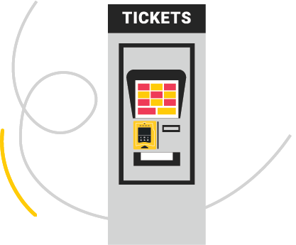 |  | 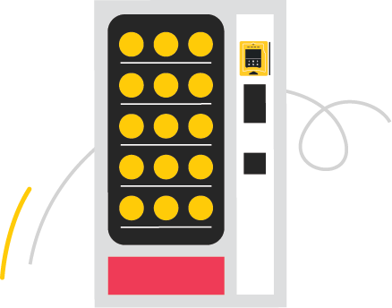

The Nayax Offering
Below is a complete list of the Nayax devices that operate with pulse functionality.
The term Touch Devices refers to all Nayax devices that include touch screens, such as the Nayax VPOS Touch, Onyx, Fusion and so on.
 | Touch Devices | Amit 3 | Revision 2.2 & 2.5
Device | 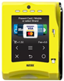  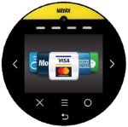 | 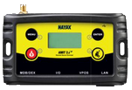 | 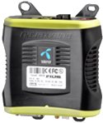
VPOST/Onyx |  | 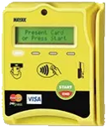 | 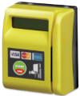
Device Cables * | 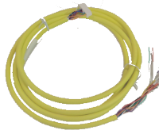 | 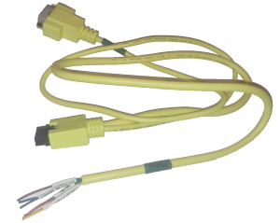 | 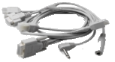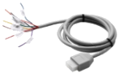
Cables Description | One cable that connects the device to the machine | One cable that connects the device to the machine | Nayax MDB Cable & MDB - Pulse Adaptor Cable
Table 1 - Pulse functionalities

For more information about Nayax cables, refer to Nayax Cables.
 | Touch Devices | Amit 3 | Revision 2.2 & 2.5
Pulse  Wire Labels | 6 Pulse:  Pulse 1  Pulse 2  Pulse 3\Fuji TXD  Pulse 4\Fuji RXD  Pulse 5  Pulse 6 | 2 Pulse:  Pulse 1/Fuji RXD (Orange)  Pulse 2/Fuji TXD (Yellow) | 1 Pulse:  Pulse
Wires for Power Adapter | 2 * AC/DC IN+ (Red)  2 * AC/DC IN - (Black)  VCC (Light Blue)  GND (Brown & Grey) | AC/DC IN+ (Brown)  AC/DC IN - (Green)  VCC (Black)  GND (Red) | AC/DC IN+  AC/DC IN -  VCC  GND
Additional Wires | EX Pulse Inhibit (Purple)  Door Open (Light Green)  Temp (Temperature) | EX Pulse Inhibit (Purple)  Door Open  Temp (Temperature) | Pulse Inhibit
Table 1 - Pulse functionalities

Pulse Functionalities

Pulse Purchase Flow
This is how credit is provided to the machine:
- The Nayax device creates a short-circuit pulse line to the ground point.
- The machine detects that specific pulse.
- Each machine needs a specific type and amount of pulse to start working.
- Once the pulse is detected, the device will start working.
- The device returns to idle mode when the lever is opened.

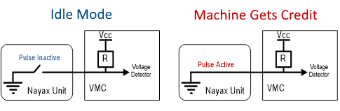
Figure 1 - Pulse purchase flow

Available Pulse Types

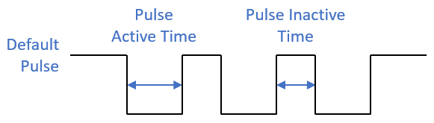
Default Pulse
Figure 2 - Default pulse
- Voltage in idle mode (pulled-up)
- Pulse drops the voltage (pulled-down)
This is referred to as Normally Closed
Invert attribute definition = No Invert

Invert Pulse
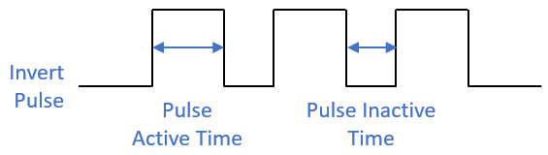
- No voltage in idle mode (pulled-down)
Figure 3 - Invert pulse
- Pulse provides voltage (pulled-up)
This is referred to as Normally Open
Invert attribute definition = Invert Pulse X

Closed Circuit
- No voltage (pull-down) in either mode
- Pulse closes the electric circuit
Used for coin mechanisms, i.e., use Normally Open
The pulse wires provide a 0.2V voltage level for up to 200mA current outputs. If a higher current is required, connect the pulse wire to the VCC or to an external power supply.

Pro Tip

Use the pulse pull-up attribute in the event that an external pull-up is connected.

Hardware Installation
Below are the hardware installation steps for all Nayax integrated POS for pulse machines:

Step 1: Open the machine and select a flat location for the installation.
Step 2: Drill 4 holes into the machine, using the plastic plate as a stencil.
Step 3: Drill a 14mm hole into the machine for the cables to pass through.
Step 4: Connect the cables and secure the device, as follows:

  - For VPOS Touch and Onyx integrated POS devices
    - Connect the cables - refer to Section 4.1 - Device Cable Connection.
    - Secure the device to the selected location on the machine.

  - For Amit/ VPOS devices
- Connect the cable between the VPOS and the Amit.
- Place VPOS on the selected location on the machine.
- Connect the Amit cables - refer to Section 4.1 - Device Cable Connection.
- Place the Amit device inside the machine.
- Secure the device from inside using screws.

Step 5: Connect the device to the power supply - refer to Section 4.2 - Device Connection to Power Supply.
Step 6: Connect the device to the machine - refer to Section ‎4.3 - Device Machine Connection.
Step 7: Set up the NayaxVend (DCS) attributes for a pulse machine - refer to Section ‎5 - NayaxVend (DCS) Attributes Setup.

Pro Tip

The rear plastic plate screws are Philips M4. In addition, make sure to use the tightening torque Level 3.

Device Cable Connection
After connecting the device to the machine (following the instructions in section 4: Hardware Installation Step 1-4 above), follow the steps in the detailed explanation below:

For Nayax touch devices, refer to the relevant VPOS Touch Installation Guide >
Appendix 1 - Dissemble the Device.

Step 1: Connect the cable to the device. A click is heard when connected.
Onyx | VPOS Touch | Amit 3.0
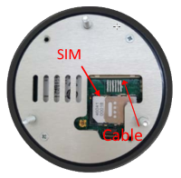 | 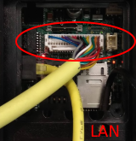 | 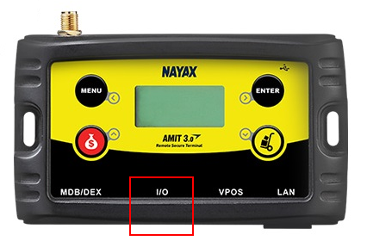
Connect cable to the main connector |  | Connect cable to the I/O connector

Figure 4 - Device cable connection

Step 2: Connect LAN (if needed).
Step 3: Connect the antenna to the black antenna cable.
Step 4: (Optional) For Touch devices, connect the rear plastic closure.

Device Connection to Power Supply
The Nayax device requires either a 10VDC - 24VDC or 10VAC - 42VAC / 2A power supply.

The power supply can be provided from either:
- The Nayax 12VDC/ 2A power adapter provided with the kit, on request.
- The machine itself.

Connect the power adapter to the cable wires:
AC/DC IN+ and AC/DC IN- (or GND).

Pro Tip

While using the AC power supply, make sure that the GND wire is not short-circuited with any of the power inputs (+24VAC/DC and -24VAC/DC).

Device Machine Connection
Connect the pulse wire(s) to the machine according to the following options:
  - Wire Connection Without a Relay - Requires an electronics background.
  - Wire Connection Using the Relay - Fast and easy, no electronics expertise required.
  - wire connection to the coin mechanism (instead of the machine itself) - Used in situations where cash sales are read from the coin mechanism.

Wire Connection Without a Relay
Caution: This type of installation requires expertise in electronics.

Step 1: Connect the power wires.
Step 2: Connect the pulse wires.
Step 3: In case voltage is required for pulse, then connect the VCC (5V) with a resistor to pull-up the voltage in the pulse wire.
Step 4: In most cases, a 1K Ohm resistor is suitable. The calculation for the resistor is performed by the electrician based on machine specifications.

Pro Tip

There is no need for VCC in closed-circuit mode. Refer to the image below.

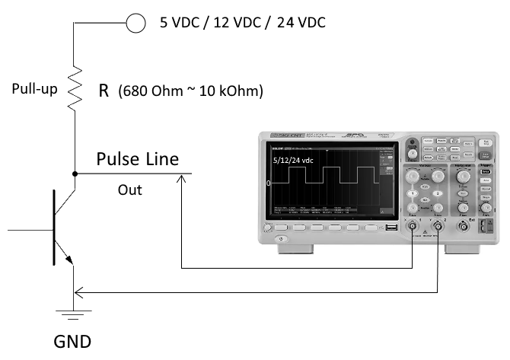
Figure 5 – Connecting the device to the machine without relay

Wire Connection Using the Relay
Connect the wires as per the wiring scheme (refer toError! Reference source not found.6 below) or purchase a cable with connectors, from Nayax.
  - Relay Device Connection
VPOS Touch & Onyx Devices | 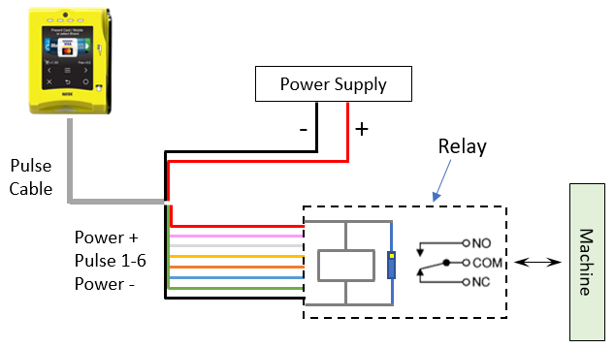
Amit | 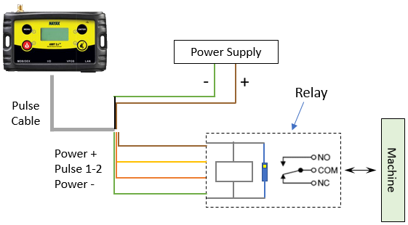

Figure 6 - Relay device connection

The machine is connected to the COM output either with Normally Open (NO) or Normally Closed (NC) outputs depending on the pulse type required (refer to Section ‎‎3.2. - Available Pulse Types).

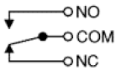

Figure 7 - Wiring scheme

In case high voltage is required to operate the machine, connect a dedicated power supply to the COM output on the relay output.

  - Relay Machine Connection
This is a relay connection scheme that connects to the wires.
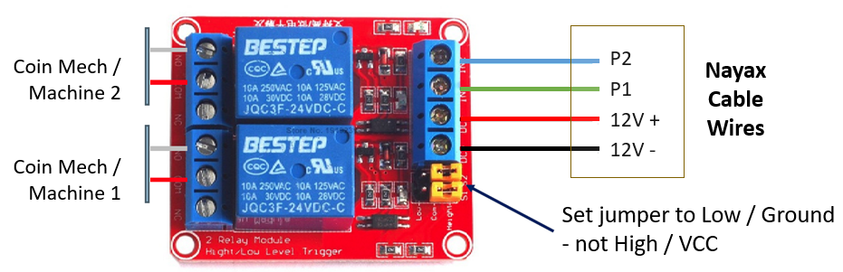
Figure 6 - Relay connection scheme
It is possible to purchase a VPOS Touch or Onyx device relay connection set which includes:
- Relay (either a 2-channel / 6-channel relay)
- Pulse cable comprising of:
  - Power adapter - connect to the power supply
  - Relay connector - connect to the relay (2 or 6 channels)
- Relay box

2-Channel Relay | 6-Channel Relay
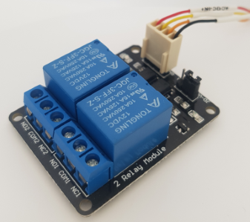 | 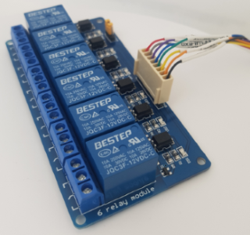
Figure 7 - Channel relay wire connection to the coin mechanism

Wire Connection to the Coin Mechanism
Note: a coin mechanism is not mandatory for installation, but can be used for various pulse machines.
Mechanical Coin Mechanism
Connect the two wires to the Normally Open (NO) and COM terminals.

Pro Tip

The connection can be made from either side.

  - Digital coin mechanism and 10-pin flat ribbon cable
- Connect pin number 1 to the COM (see Pin 1 in Figure 8 below).
- Connect one of the pins (3-10) programmed to the Normally Open (NO) terminal.
  - There are various combinations of pin cables (8-pin, 10-pin, 12-pin 16-pin and so on). 10-pin is the most commonly used cable.
Mechanical Coin Mechanism  with two wires | Digital Coin Mechanism  with 10-pin flat ribbon cable
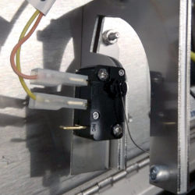 | 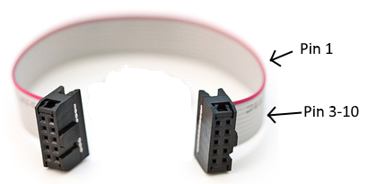
Figure 8 - Coin mechanism

Additional Cable Wires
The pulse cable includes additional wires mentioned below that receive information from the machine.
- Inhibit 1 - Disables the device while the machine is in use, so that the additional credit cannot be charged.
- Door Open - Sends an event alert to the Nayax server when the door opens.
- Temp - Sends the machine temperature to the Nayax server.

NayaxVend (DCS) Attributes Setup

Configuring Attributes in NayaxVend
Follow the process below to configure the pulse attributes in NayaxVend.
Step 1: Configure General Pulse Attributes at the Machine level
- Log in to NayaxVend using your credentials.
- Click on Operations - Machines.
- Select the relevant machine from the hierarchy.
- Click on the General tab.
- Under the Pulse/ccTalk section, configure the attributes shown in Figure 11 below.
- Click Save to store all the information.

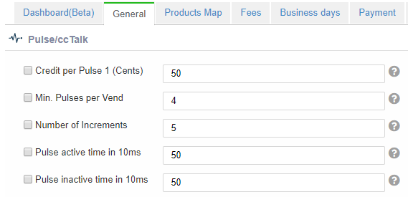
Figure 9 - Pulse/cc talk attributes
Step 2: (Optional) Assign the Attributes to the Machine
- Click on the Attributes tab.
- Under the Group filter, type in Pulse/ccTalk.
- From the Machine Attributes displayed, check the boxes for the Pulse Attribute Ids shown below.
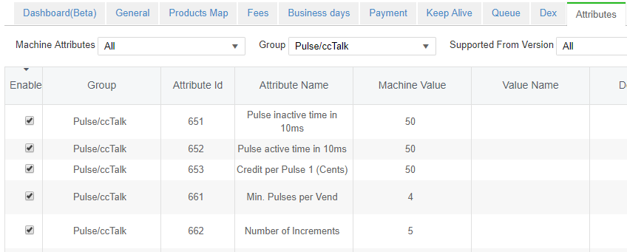
- Click Save to store all the information. Proceed to Step 1 above to continue with the process.

Figure 10 - Assigning Pulse/cc talk

General Attributes
These attributes can be configured for all three - refer to Section 5.3 - Pricing Methodology.

Attribute-Naming Convention

Device | No. of Pulses | Attributes Names
Amit | 2 | Pulse attributes contains with 1 or 2  For example:  - Credit per Pulse 1 (cents)  - Credit per Pulse 2 (cents)
Touch devices | 6 | Pulse attributes contains with 1-6  Example:  - Credit per Pulse 1-6 (cents)
Table 2 - Naming attributes
Important: The value separator used in Touch devices attributes (1-6) is semi-colon (;) and not comma (,).

General Mandatory Attributes
The pulse attributes set out below are required to be configured for Single/ Multi Price pulse modes. (They are not applicable for the count-up mode.)
  - Pulse Active and Inactive time
There are three available configuration pairs. Each pair has the following two attributes:
- Pulse Active Time - Determines for how long the device will short-circuit the pulse line to ground.
- Pulse Inactive Time - Determines how long the pulse must be inactive before sending the next pulse.
Select one pair from the available list of attributes:
- Pulse Active Time in ms, Pulse Inactive Time in ms (Amit - Option 1).
- Pulse Active Time in 10ms, Pulse Inactive Time in 10ms (Amit - Option 2).
- Pulse 1-6 Active Time in ms, Pulse 1-6 Inactive Time in ms (Touch Device).

Where both pairs are configured for the Amit device, then the Time in ms overcomes the 10ms.
  - Number of Pulses per Vend
- The number of pulses that are being sent to the machine when the vend is approved.
- Not in use for price list.
  - Credit per Pulse
- The amount charged for each given pulse.

Inhibit
The machine uses the wire labeled Inhibit to indicate that it cannot currently receive credit. When an Inhibit is detected, the device will not accept cards, leading to no credit details being accepted and no pulses being provided by the device.
  - Inhibit is detected
The inhibit line hold voltage of 3.3 volt. The machine needs to pull down the voltage (connect it to ground) to change the inhibit.
  - Pulse Inhibit
Optional Inhibit Values:
- 0 - Inhibit disabled (Nayax ignores inhibit)
- 1 - Inhibit enabled and active when machine sent logic 0 (low voltage)
- 3 - Inhibit enabled and active when machine sent logic 1 (high voltage)
- 5 - Activate External MDB Credit (pulse on "Pulse IN1" will start free MDB transaction)
- 9 - Enable External Sure-Vend Sensor for MDB
- 13 - Activate External MDB Credit + External Sure-Vend Sensor
- 16 - Multi Inhibit Enabled and Active when logic '0' received from VMC (relevant for VPOS Touch and Onyx devices only)
- 32 - Multi Inhibit Enabled and Active when logic '1' received from VMC (relevant for VPOS Touch and Onyx devices only)

  - Inhibit Event Timeout (sec)
- Time in seconds after which an alert will be sent to the server when the device is Inhibited by the machine.
- Default: 90 seconds.

General Optional Attributes

  - Pulse line welcome message
You can change the default text (Choose Desired Machine) displayed when the machine is in idle mode (except for the count-up mode).

  - Post delay in sec
The waiting time in seconds after a pulse transaction, before allowing the next transaction.

  - Pulse Invert
Pulse invert converts to the pulse signal.
Invert | Inactive Signal | Active Signal
No | High | Low
Yes | Low | High
Table 3 - Optional attributes
Refer to Section 3.2 - Available Pulse Types.
  - Pulse Pull-Up
Must be configured when pulse has external pull-up.
Refer to Pull-up installation, Section 3 of the Appendix.

Pro Tip

To prevent the device reading its own pulse as an input, make sure to appropriately configure the Pulse Inactive Time.

  - Pulse Processing Message
We have added the ability to replace the “processing” animation, so you can communicate important information to the customer on what to do/not to do during the purchase process. For example:

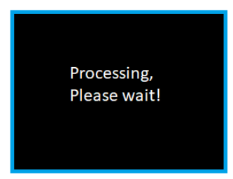 | When sending long pulses (taking a relatively long time) to the machine, to tell the customer to wait until pulses finish, to get the full service from the machine.
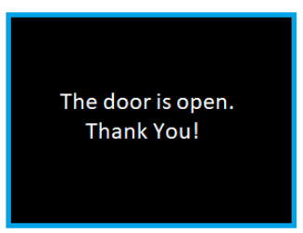 | To prompt the customer that the bathroom gate is now open, and they should enter and not wait any longer.

The configuration is via attribute 166:
NULL: Maintain current behavior.
String: Activate the new behavior - presenting the string instead of the "processing" animation. Inserting "\n" into the string will indicate to go down to the next row.
@$- to clear the string.

  - Pulse IN Counter
Each pulse line is an output (sends credit to a machine) and input. The device can detect pulse on the same pulse wire that is provided by other payment devices (e.g. the coin mechanism). Pulse IN Counter defines the number of pulses needed to be sent to report the cash usage:
  - 0 - Disabled
  - >0 - Device sends a Pulse Cash Report to the server for every similar pulse count set in this parameter.
  - Reported Price = Pulse IN Counter * Credit per Pulse 1.
  - Coins insert Timeout
  - LCD group > Remove LCD Message
Excludes specific LCD messages that speeds up the transaction process:
- 0 - All server response
- 1 - Successful server response - removes the last payment information screen
- 2 - Thank you

  - Language/Audio group > Remove Audio Message
Excludes audio messages like: Thank You, Card Approved, Card not Approved, …

  - Device Parameters > Door Open Functionality
To use the door open line as button source, the machine should short-circuit the door open wire via the switch connected to ground.
- When the machine door is closed, the pulse is connected to the ground, the device will send ‘door open’ alert, and the device will be disabled.
- When the machine door is opened, the pulse is not connected to the ground, and the device will send ‘door close’ alert.

Optional values:
- As Door Open - Sends an alert when the door is opened.
- As Cash Collect – To report Cash Collection to the server.
- As Increment Source - Refer to Multi Price Additional Attributes.
- As Cancel – Refer to Stop Count.

  - Pulse Fiscalization
Fiscal monitoring is now possible on pulse machines with the use of a supporting external fiscal device.
We differentiate between two types of payment methods:
- Fiscalized payments: credit card/Apple Pay/Google Pay and other payment apps
- Non-fiscalized payments: prepaid/Monyx/QR

Using the Nayax Core platform, we offer a choice of two modes of operation. In order to set the desired mode, use Attribute 601 – “Pulse Fiscal” under the Pulse/ccTalk category.
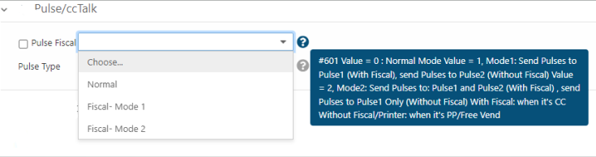
Mode 1 – Where regulations require payments to go through an external fiscal device, connect both pulse line 1 and pulse line 2 to automatically send fiscalized payment methods (pulse line 1), and non-fiscalized payment methods (pulse line 2).
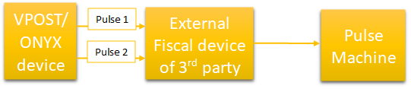
Mode 2 – Connect pulse line 1 to activate the pulse machine. Where receipts are required for fiscalized payment methods, also connect pulse line 2 to the printer. (Note: non-fiscalized methods use only pulse line 1).

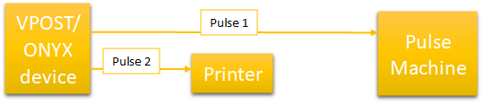

Pricing Methodology
The device operates in several pulse pricing modes suitable for different uses. The pulse pricing mode options are as follows:
Pricing Options | Price defined by | Description | Number of Machines *
Single price per pulse line | Operator | 1 predefined price per pulse line | 1-6
Multi price for a machine | Consumer | Several predefined prices per machine  Linear price increment or price list | 1
Count-up pricing | Per usage | Price calculated by usage time  Suitable for long operations, such as massage chairs, campsite showers, and more | 1
Table 4 - Pricing methods
* Important: The number of machines indicates the pulse lines (wires) in use.
For all pricing options, connect pulse line 1 only; except for Single Price per Line where a connection can be made to several pulse lines (1-6).
Single Price - Pulse Lines | Multi Price -  Linear Increment | Multi Price -  Price List | Count-Up  Price
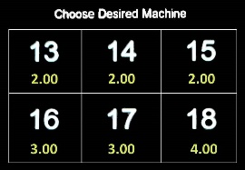  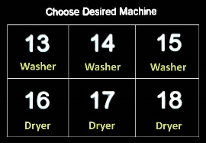 | 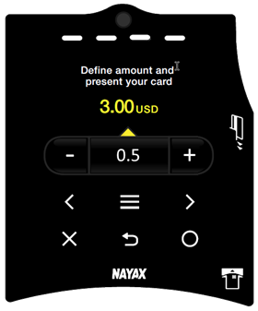 | 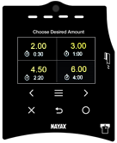 | 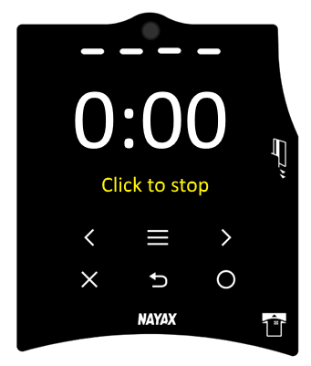
Figure 11 - Pricing mode options

Single Price per Pulse Line
This is the most common use of the pulse mode. It sets the preliminary definition for the Number of Pulses per Vend and is used for:
- 1 pulse for 1 machine (used only for 1 pulse)
- 1 pulse for several machines
- Several pulse units for several machines
  - For several pulse units for one machine, refer to Section‎ 5.5 - Multiple Price for a Machine.

Single Price Configuration per Nayax Device
  - Amit + VPOS
- Includes two wires for pulse management.
- Configuration example:
  - Decimal Place = 2; Currency = USD
  - Pulse Active Time in 10ms = 20
  - Pulse Inactive Time in 10ms = 20
  - Credit per Pulse 1 = 50
  - Number of Pulses per Vend 1 = 5
  - Result = Pulse Line 1 will send 5 pulses and cost $2.50

  - Touch Devices
In cases where the machine requires a single price only, use the price configuration for Amit + VPOS listed above. In case of multiple machines, use the following option.
- Includes six wires for pulse management.
- The value is separated by a semi-colon list for the pulse length that you want to use
- Configuration example:
  - Decimal Place = 2, Currency = USD
  - Pulse 1-6 active time in ms = 200; 200; 200; 200; 200; 200
  - Pulse 1-6 inactive time in ms = 200; 200; 200; 200; 200; 200
  - Credit per Pulse 1-6 = 25; 25; 25; 25; 25; 25
  - Number of Pulses per Vend 1-6 = 8; 8; 8; 12; 12; 16
    - Displays 6 prices: 3*$2, 2*$3, and 1*$4
  - Number of Pulses per Vend 1-6 = 8; 8; 8; 8
    - Displays 4 prices of $2

- Pulse Identifier (1-6) - The pulse lines identifier seen in idle mode that identifies the machine in the room. The default values are 1 to 6.
- Pulse Title (1-6):
  - Text seen below the identifier that describes the pulse line.
  - When the Pulse Title ID is defined, the screen switches every 3 seconds, showing the Price/ Title.
  - Title examples:
    - Air and Vac
    - Washer and Dryer
    - Vanilla and Chocolate
Identifier
Price
Title
Figure 12 - VPOS Touch identifier
- Relay mode option:
Instead of sending pulses, the device can also work in relay mode, meaning that it can change the output level for activating any kind of motor. This behavior replaces the need for an external timer that transforms pulses to time for activating the motor.
To enable the relay mode, set the value to Time per Pulse 1 (sec) (Attribute 705) and then the device will activate the machine for time calculated by:
Time per Pulse 1 (sec) x Number of Pulses per Vend 1.
In such cases, the device will present the time count on the screen.
For example:
  - Number of pulses per vend = 4
  - Time per pulse (sec) = 10
  - The machine will be active for 40 seconds

There are 2 options in the relay mode:

  - Option to stop in the middle (no pay back on the time left)
  - No option to stop. The time will be completed without option to stop before the end.
Select the desired option by setting Pulse Options (Attribute 722) to 32.

- Credit per vend option:
This is an option to set the credit per vend instead of credit per pulse, as an alternative to the formula of Price = Credit per Pulse * Number of Pulses. If you to set a price that can not be a result of this formula.
For example:
3 pulses per vend and price of 7.00. To achieve this, the user can set the credit per pulse to 700, the number of pulses per vend to 3, and set pulse options (Attribute 722) to “credit per vend”(=4). The credit per pulse will then become credit per vend.

Pulse 2 as Prize Win
  - Prize Win Logic
Prize Win functionality allows tracking when the machine releases a prize to the consumer. To use this functionality, the Pulse Feedback Time needs to be configured. After payment is made, the Prize Win incoming pulse must occur faster than the Pulse Feedback Time. In addition, the machine Prize Win wire should be connected to the pulse 2 wire in the Nayax cable.

  - Prize Win Configuration
To use the Prize Win option, define these attributes in addition to the regular attributes:
      - Pulse IN2 Counter - Set value to 1
      - Pulse Feedback Time - The time interval between the payment to the Prize Win pulse

Pulse Combo Machines
Nayax has several configuration types for a pulse combo machine. These configurations are used when several machines are connected to the same Amit device. In addition, define the relevant mode for the machine to operate in.
The configuration is set in the Cashless MDB address attribute in the MDB section.
There are three combo machine values:
Options | Description | Pulse
Pulse Switch Mode | Select the machine unit to operate via a switch and present a card. | Pulses are sent by “Number of Pulses per Vend”
Pulse Telemetry Mode | Present a card and click one button from the two available options. | Pulses are sent by “Number of Pulses per Vend”
Pulse Telemetry Relay Mode | Present a card and click one button from the two available options. | Pulses are sent by “Time per Pulse Attribute”
Table 5 - Pulse MDB attributes

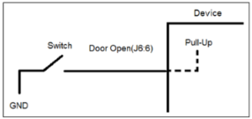
  - Pulse Switch Mode
The machine consists of two units, and the switch defines to which unit the pulse will be sent.
Present card will send the pulses according to the switch selection.
Wiring
Figure 13 - Pulse mode with switch
- Send pulse - use Pulse 1 & Pulse 2
- Read switch mode - use Door Open (J6:6)

  - Pulse Telemetry Mode (Use Buttons)
When selecting a specific product, the consumer will follow a vending machine process like this:
- The consumer presents their card.
- The consumer is prompted to choose the desired product.
- The consumer selects a product at the press of a button.

Wiring
- Send pulse - Use Pulse 1 & Pulse 2
- Button 1 - Use Door Open (J6-pin6)
- Button 2 - Use MCR_DT2 / PROXY_RXD (J8-pin8)
Both inputs are pulled up internally, and when the consumer presses the button, a connection is made to the ground point.

  - Pulse Telemetry Relay Mode
For the Amit device, it is possible to configure Pulse 1 and Pulse 2 as different prices/ activation times for cash and cashless transactions.
Payment | Pulse Attributes | Formula
Cash | Price for Cash | Pulse IN1/2 Counter x Credit per pulse 1/2
Cash | Time activation | Pulse IN1/2 Counter x Time per Pulse 1/2 (sec)
Cashless | Price for Cashless | Number of Pulses per Vend 1/2 x Credit per Pulse ½
Cashless | Time activation | Number of Pulses per Vend 1/2 x Time per Pulse 1/2 (sec)
Table 6 - Pulse telemetry relay mode
- To activate relay, the signal levels must be changed.
- If the relay is set to high, then it will be active when this signal is at a high level.
  - For example: If the machine needs to be active for three minutes, the device will change the signal to a high level for three minutes (refer to Figure 16 below).
- Relay mode can support dual machines.
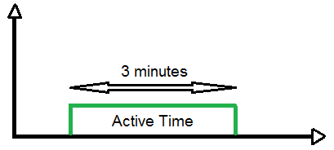
Figure 14 - Pulse telemetry relay mode
Wiring
- Touch Device - One output is connected to PULSE 3(J8:5) and the second output is connected to PULSE 4(J8:7).
- Amit - One output is connected to MONITOR_232_TX(J8:4) and the second output is connected to MDB_RS232_TX(J6:11).
Refer to ‎4.4.3 - Wire Connection to the Coin Mechanism.

Multiple Price for a Machine
This mode enables the user to select a price from a set of predefined prices. For each price, the Nayax device will send the required number of pulses to the machine.
  - Main Attribute - Pulse Increment
Defines the work and pulse modes that are required to be sent.
  - 0 or empty - multiple price mode is disabled
  - Single value - Use Linear Price Increment
  - Comma separated list - Use Price List options

Linear Price Increment Attributes
  - Increment selection
- Touch Device - Click the +/ - icons on the touch display to either increase/ decrease the amounts.
- Amit + VPOS - Each time the VPOS button is pressed, the next increment will be selected.

  - Attributes for all Nayax devices (excluding Amit)
Figure 15 - Increment display
Pulse Attributes | Description
Credit per Pulse | The amount charged for each given pulse
Min. Pulses per Vend | Minimum pulses per vend value
Pulse Increment | Number of pulses per increment (whole number)
Number of increments | Number of increments per vend

Table 7 - Linear price increment (all devices)

Formula: Price = Credit per Pulse * Number of Pulses
Calculation example:
- Credit per Pulse = $0.5
- Min. Pulses per Vend = 4
- Pulse Increment = 2
- Number of increments = 5
- Values displayed: 2, 3, 4, 5, 6
- Pulse sent to machine: 4, 6, 8, 10, 12

Pro Tip

The linear increment is limited to a maximum of 255 pulses per vend.

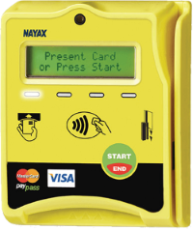
Price List Attributes
  - Increment selection
- Touch Device - Click a price option on the screen.
- Amit + VPOS - Each time the VPOS button (Start / End) is pressed, the next increment will be selected.
Figure 16 - Price list display
Pulse Attributes | Description
Pulse Increment | The number of pulses per increment, defined as a comma-separated list.
Pulse Increment Prices | The price per number of pulses sent, defined as a comma-separated list.  If not defined, the price is calculated as follows:  Credit per Pulse 1 * Number of Pulses
Pulse Options | Mandatory when the “Pulse Increment Price” attribute is defined.  - Use Price Array for Outgoing Pulses - Select this option for cashless configuration only.  - Use Price Array for Incoming Pulses - Select this option for cash configuration only.  - Use Price Array for Outgoing and Incoming Pulses - Select this option for both and cashless configuration.
Table 8 - Price list attributes
Calculation example:
  - Credit per Pulse = $0.5
  - The user can select 3, 5, 6, 10, 18, 22 pulses per vend
  - Price will be: $1.50, $2.50, $3, $5, $9, $11 accordingly

Pro Tip

For the Touch Device, price list is limited to six different price options.

Multi Price Additional Attributes
  - Price Change for Increment Modes
Touch Devices:
- For Linear Price - The price change is made on the touch screen itself.
- For Price List - The different prices are displayed on the touch screen.

In the Amit & VPOS devices, both for Linear Price and Price List, the consumer needs to press a button.
To configure the VPOS button, as an Increment Source use:
- Pulse group > Increment Source attribute > External Reader Cancel Button.
To configure an external button, as an Increment Source use:
- Devices Parameters group > Door Open Functionality attribute.
- To use the door open line as the button source, create a short circuit between the door open and GND wires to indicate a button press.

  - Payment group - Transaction Timeout
Enabling the option to reset the pulse index:
- If 0 - No reset
- If > 0 - Reset after Timeout (sec) / after Decline / from external line - J8:8 (MCR_DT2)

- Relay mode option:
Instead of sending pulses, devices can also work in relay mode. This means changing the output level to activate any kind of motor. This behavior replaces the need for an external timer which transforms pulses to a time frame for activating the motor.

To enable the relay mode, set the value to Time per Pulse 1 (sec) (Attribute 705) and then the device will activate the machine for the time frame calculated by: Time per Pulse 1 (sec) x Pulse Increment (Index). The device will present the time count on the screen.
Another option is to use the Time per Pulse 1-6 (sec) array to set a time per pulse for each product separately.

Example 1:
  - Pulse Active Time in 10ms = 20
  - Pulse Inactive Time in 10ms = 20
  - Pulse Increment = 4, 6, 9, 12
  - Credit per pulse 1 = 50
  - The machine will be active for 20 seconds for the first product, 40 for the second, 60 for the third, 80 for the fourth.
Example 2 – setting a time per pulse for each product separately:
  - Pulse Increment = 2, 4, 6, 8
  - Time per Pulse 1-6 (sec) = 10, 12, 16, 20
  - The machine will be active for 20 seconds for the first product, 48 for the second, 96 ifor the third, 160 for the fourth.

There are 2 stop options on the relay mode:
  - Option to stop in the middle (no payback on the time left)
  - No option to stop - the time will be completed without an option to stop before the end.
You can control this by setting Pulse Options (Attribute 722) to 32.

Count-Up Mode – Pay as You Go
Count-up mode machines are intended for long operations, such as purchase applications for car washes or campsite showers.
  - The process:
- The consumer swipes their card.
- A configurable maximum charge is held on the card, and a signal is set on the vending machine.
- The device holds this signal until the consumer cancels the transaction by pressing the stop button, or the maximum charge is reached.
- The LCD display is updated accordingly, and periodically displays the amount that has been charged.

Count-Up Active/ Inactive Time
Count-up machines are machines that receive pulses from an external source, and operate/ stop accordingly.
- The machine operates in Pulse Active Time
- The machine stops operating in Pulse Inactive Time.

Pulse Active time
Pulse Inactive time
Figure 17 - Count-up active/ inactive time diagram

Count-Up Mode Attributes

Pulse Attribute | Description
Count-Up Minimum Charge | The minimum amount that the consumer will be charged, whether this amount has been reached or not.
Count-Up Maximum Charge | The maximum amount that the consumer will be charged, capping the price of the vend.
Count-Up Delta Time | The charge is performed according to delta time.  For example, a device will be charged $0.25 for every 6 seconds.
Count-Up Credit per Delta Time | The value in cents charged in every delta time.
Count-Up Direction | Count up/ down + Stop when credit finish
Pulse Options | To configure the count-up pulse (see Section 5.6.6 below: Count-Up Pulse)
Table 9 - Count-up mode attributes

The following rules should be taken into account for the count-up functionality to work as expected:
- Maximum Charge = Minimum Charge
- Maximum Charge = Less than 0
- Delta Time = Less than 0
- Credit per Delta Time = Less than 0
It is mandatory to use Pre-Authorization and not Pre-Selection to enable payment by credit card.

- To use a credit card: MDB section > MDB Flags = Flags Disabled
- To use a prepaid card: Payment section > Payment Flags = any Pre-Authorization value like “no flags set” or “Server Discount for Cashless”

Buying Process
Figure 18 - Buying process

Machine stops because
5*CPDT > Maximum,
Total charge is 4*CPDT
Time
1 delta time
2 delta time
3 delta time
4 delta time
5 delta time
Run
Stop
Run
Run
Run
CPDT = Credit per Delta Time
= Total charge as time varies
Total Charge vs. Time
Count-Up Minimum
Count-Up Maximum
Total charge
Count-Up Minimum
2*CPDT
3*CPDT
4*CPDT

The buying process:
- The consumer presents their card.
- The card requests authorization for the count-up maximum charge amount.
- Once authorization has been obtained, the machine starts to operate.
- The consumer can stop the machine’s operation at any given time.
- With every Delta Time (DT) elapsed, the total charge is updated at the beginning of the delta time with an amount predetermined by the machine's operator (Credit per Delta Time).
- At the end of the operation, the consumer’s card is charged the total amount as per the mentioned formula - <Delta Time Count> * <Credit per Delta Time>.
- The Total Charge will be between the minimum and maximum charges.

  - Count-Up Examples
- Constant Parameters:
  - Credit per Delta Time = 12
  - Delta time = 10
- Scenarios:

Time (sec) | Min. | Max. | 0-10 | 10-20 | 20-30 | 30-40 | 40-50 | 50+
Example 1 | <=12 | 60 | 12 | 24 | 36 | 48 | 60 | Stop
Example 2 | 36 | 60 | 36 | 36 | 36 | 48 | 60 | Stop
Example 3 | 40 | 70 | 40 | 40 | 40 | 48 | 60 | Stop *
* 12 times 6 = 72 which is more than the maximum (70), so the machine stops working.
Table 10 - Count-up scenarios

Stop Count-Up
To stop the count-up process and end the transaction before the maximum count-up is reached:
- Touch Devices - Use the X button on the Touch device.
- Amit & VPOS - Use the VPOS button.

To configure a stop button as an external button (i.e. instead of the built-in button), configure the attributes as follows:
- Devices Parameters group - Door Open Functionality attribute - Cancel.

To use the door open line as the button source, create a short circuit between the door open and GND wires to indicate a button press.

Count-up direction drop down > Stop when credit finish – the pulse will continue, even when the stop button is pressed, until the amount to be paid has been used in full: until delta time is finished and at least the minimum value is fulfilled.

Power off
If the power to the machine is turned off due to any reason while the device is in operation, the machine stops functioning and the Total Charge amount is saved in its memory. When the power is restored, the consumer is charged for the Total Charge.

Count-Up Pulse
We have introduced a new feature that enables connection of the Nayax device with a straightforward pulse connectivity. This helps improve the user experience and product reliability, allowing your customers to stop at any time and pay for the exact time/ value for which they used the machine.
The relay solution required that the VPOST/ONYX be connected both to the machine and the coin mechanism – directly before a motor - which caused some logistical issues. It is now possible to offer a "pay-as-you-go" experience, with regular pulse connectivity, using a parallel connection between the VPOS/ONYX and the coin mechanism, and connecting them both to the machine. This count-up pay-as-you-go feature is enabled by the sending of a pulse burst at a constant rate, just before the machine stops, to keep it going.

Note: This feature is applicable for preauthorization flows only
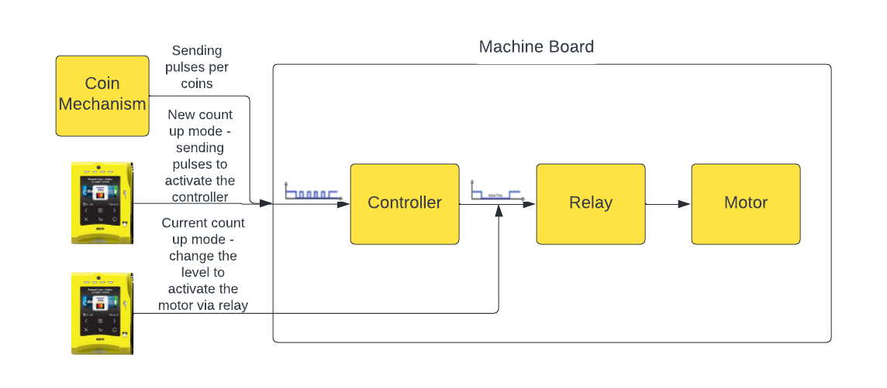
Figure 21 – Count-up pulse in action

The diagrams below show the Nayax device’s connectivity points for each of the count-up modes:
Behavior of the previous Count-Up as a Relay functionality:
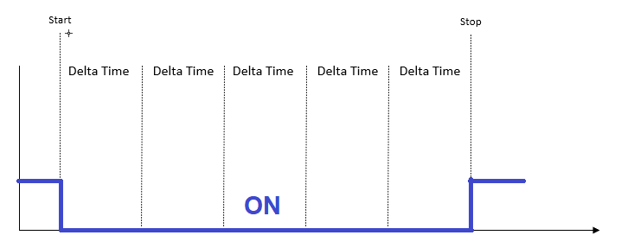
Figure 191 – Nayax device connectivity points in relay

Behavior of the new Count-Up as Pulse functionality:
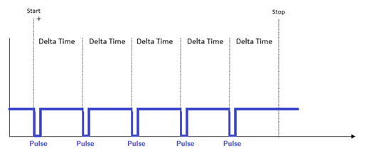
Figure 202 - Nayax device connectivity points in pulse

Count-In Mode
As an extension of the count-up mode, the count-in mode defines the amount to pay according to pulses provided by the machine (input line), rather than according to the amount of time that has elapsed.
  - Full scenario:
- The consumer presents their card:
  - The device obtains authorization for the count-up maximum charge.
  - A signal is sent to the vending machine in Pulse 1 to start working.
  - The machine pull-down the inhibit wire.
- The consumer selects a product in the machine (there is a configuration for no product selection)
  - The machine sends pulses to the device in Pulse 2.
- Stop session
  - This can happen if:
    - The consumer presses the Stop button on the machine - pull-up Inhibit.
    - The consumer presses the Stop button on the device – send pulse on Pulse 1.
    - The amount payable reaches the maximum charge value - send pulse on Pulse 1.
  - The device performs the settlement.
  - The device updates the machine upon settlement - send pulse on Pulse 1.
  - The machine pull-up Inhibit, else the device send alert to server.
- The device displays the Thanks You and Amount Charged screens.
- The device returns to idle mode.
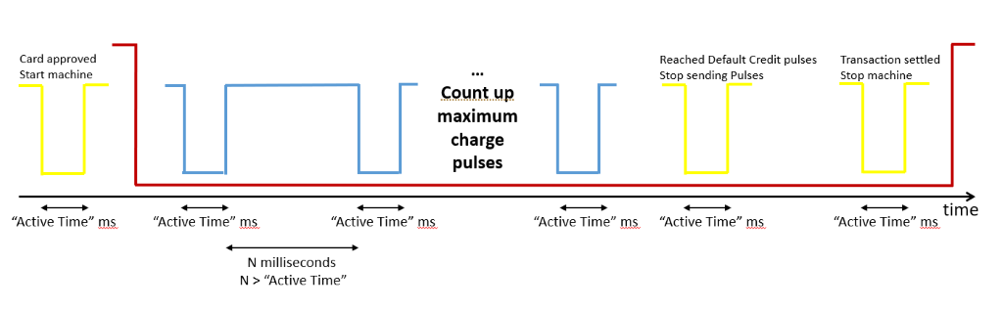
Figure 213 – Count-in mode process

Wires
Direction | Color | Wire | Description
Output | Yellow | Pulse 1 | Pulse sent upon Start, Stop & Settlement
Input | Blue | Pulse 2 | Pulse = increase price by delta credit
Input | Red | Inhibit | Machine state: up = idle mode, down = working
Table 11 – Wires
Important: Pulses 1 & 2 will have the same length (Pulse Active Time in 10 ms).

Count-In Mode attributes
 | Pulse Attribute | Description
Pulse | Count-Up Credit per Delta Time | The value in cents charged for every pulse count
Pulse | Count-Up Delta Time | Timeout between the in-pulses
Pulse | Count-Up Direction | Set value as count-in
Pulse | Count-Up Maximum Charge | The maximum amount that the consumer will be charged, capping the price of the vend
Pulse | Count-Up Minimum Charge | The minimum amount that the consumer will be charged, whether this amount has been reached or not
Pulse | Pulse Active Time in 10ms | Length of Pulse 1 (out) and Pulse 2 (price - in)  Time tolerance = 10%
Pulse | Pulse options | Where ‘Skip Choose Product in Pulse In’ is selected, the Product Selection screen will be skipped
Payment | Choose Product Time Out | Timeout for machine product selection (pull-down Inhibit)
Payment | Transaction Time Out | Timeout between program selection and first incoming pulse
VMC | Session Time Out | Timeout if Inhibit is not pulled up at end of transaction

Comparison Between Count-Up and Count-In
 | Count-Up | Count-In
Input line | No | Yes
Count-Up Direction | Count-Up | Count-In
Count-Up Maximum Charge | Count-Up Maximum Charge | Count-Up Maximum Charge
Pre-Authorization | ✓ | ✓
Price Calculation | By Time Quantum | By Counting Pulses
Transaction can be stopped immediately by the user | ✓ | ✓
Output line | 1 | 1

Frequently Asked Questions

Q. Why does the device read a false pulse input after every pulse purchase?
A. The device reads an input pulse on the same pulse line used for pulse output. To avoid reading its own pulse as inputs, the device does not sample the pulse line while sending pulses out. After the device completes sending out the pulse, it will not sample the pulse line for a time identical to the Pulse Inactive Time. The reason for the same is subject to the pulse line capacitance. Hence, it may take a while after the pulse is sent for power to be stable at the Pulse Inactive value. After a few pulse purchases (pulses out), if the device reads fake pulse inputs, you may need to re-configure the Pulse Inactive Time to comply with the machine time.
Q. Will the device randomly read fake pulses, or skip sending the pulses out?
A. To avoid this, try to change the Pulse Active and Inactive Time from ms to 10ms configuration. View definition in Pulse Inactive Time section.
Q. How can I check that the pulse is executed?
A. The device software recognizes pulses that it generates, and then gets final approval of pulse outputs, or alerts if for some reason the pulses were not generated. This may be because of some problem with the circuit, for example, if the line doesn't pull up.
The best way to check whether pulses have been executed is to buy a pulse reader and connect it to the pulse line.
If you have not bought a pulse reader, you can use the sniffer to check it out. When the pulses have been properly generated, "Pulse 1 feedback - generated by the device on Output 1" will be printed on Gtrace.

Q. How can I send a pulse prior to the DEX Read?
A. There is an option to send a pulse prior to a DEX read trial. This pulse provides an alert to the device for the DEX read occurrence. Configure the below attributes to enable this feature:

Pro Tip

The pulse will be active for the time specified in Pulse Active Time in 10ms.

The delay before a DEX read is controlled by Pulse Inactive Time in 10ms.
DEX/DDCMP Readout Options à Send Pulse 1 before DEX/DDCMP file read

Appendix

Hardware Electric Schemes

HW Pulse Interface
There is no defined standard for pulse interfacing. Below is the Nayax HW pulse output interface for measuring the pulse inputs.
HW Rev | Capabilities | Scheme
VPOS Touch | Internal pull-up  Pulse 1 & 2 | 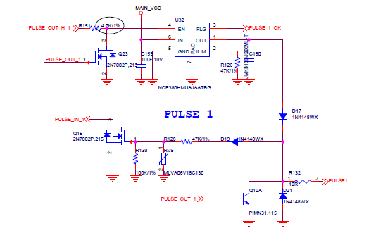
VPOS Touch | Pulse 3 & 4 | 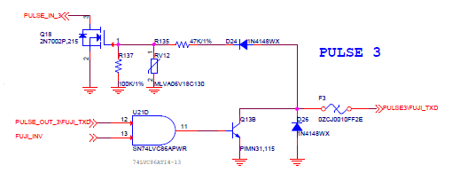
VPOS Touch | Pulse 5&6 | 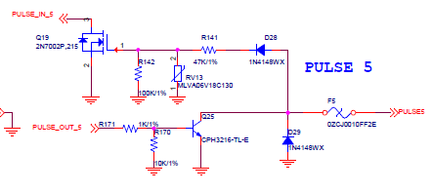
Amit 3 | Like Amit 2.5 | 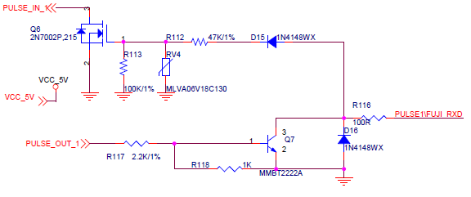
Table 10 – HW Pulse Interface

HW Rev | Capabilities | Scheme
Amit 2.5 | Audit other pulse devices | 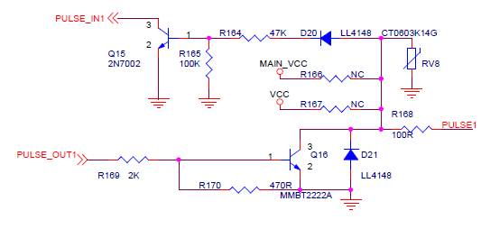
Amit 2.2 | Send a pulse out to the machine | 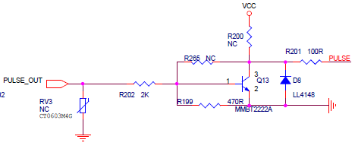
Table 11 - HW pulse interface

2. Hardware Inhibit Interface/ Door Open
Below is the Nayax HW inhibit input interface to measure the inhibit output.
Inhibit input can be between 5-12VDC.

HW Rev | Scheme
VPOS Touch | 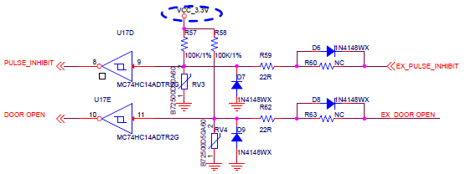
Amit 3 | 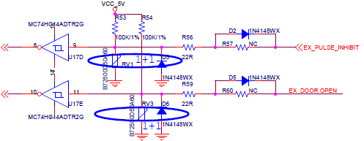
Table 12 - HW inhibit interface

HW Rev | Scheme
Amit 2.5 | 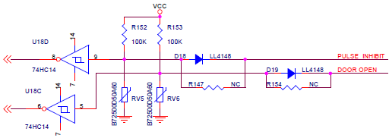
Amit 2.2 | 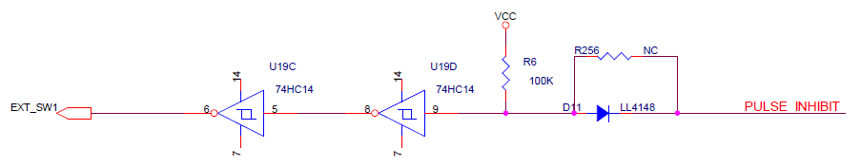
Table 13 - HW inhibit interface

Pull-up Installation
When pulse pull-up is needed, use the scheme below to install it.
Voltage and resistance should be calculated according to the machine’s need, within the following ranges:
- Voltage = 5-24V
- Resistance = 1-4KΩShould be calculated per machine needs

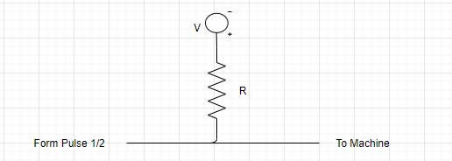
Figure 224

3. Nayax Cables
These are the current Nayax pulse cables for all Touch devices:
- C130003 - Pulse wires - default cable
- C130004 - Pulse wires + RS232 for debug

Transporter Part Numbers
Below are the Part Numbers (PNs) to place an order in Salesforce:
Product | PN for Transporter -  2-channel relay | PN for Transporter -  6-channel relay
Relay | T2CRPMEI01 | T6CRPMEI01
Box with Lexan | T2CRPMEI02 | T6CRPMEI02
Cable | T2CRPMEI03 or C130019 | T6CRPMEI03 or C130016
Full Package | T2CRPMEIV1 | T6CRPMEIV1
Table 14 - Transporter part numbers

